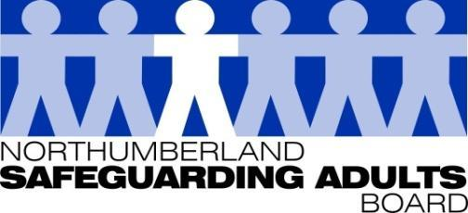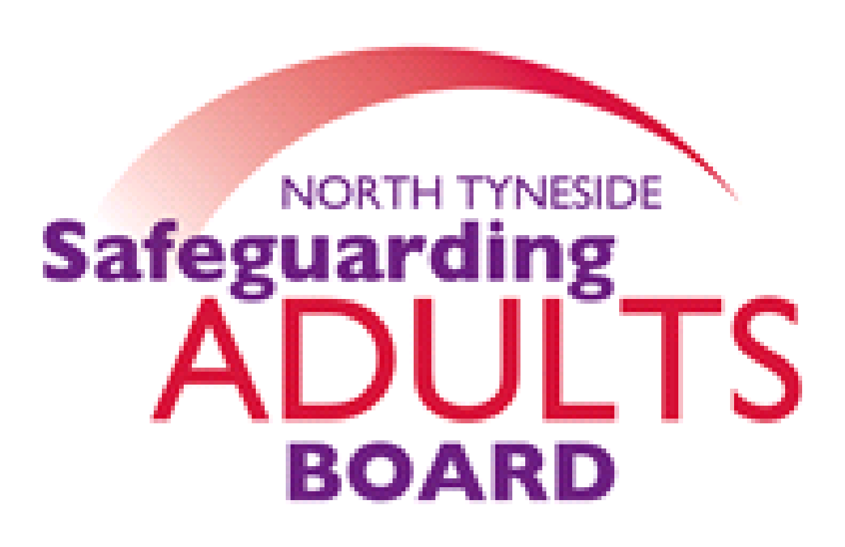

**Safeguarding adults**

**for people self-isolating**



We want to make sure that the **most vulnerable are safe** when they are self-isolating. Here are some things to think about if you are offered, or need, support during this time.



Try to use **existing and trusted community groups**. If not, could a **family** member, **friend** or **neighbour** who you know and trust help?



You can contact **Adult Social Care** on **01670 536400** if you need support or you feel unsafe. In an emergency, call **999**.

**Not sure? Don’t answer the door**

If you’re not sure about an offer of help, ask the person to leave details and talk to someone you trust about it.

**This information has been adapted from Newcastle Safeguarding Adults Board materials.**